Lab No. 5
K-Nearest Neighbor (KNN) Algorithm

Aim: To Implement K-Nearest Neighbor (KNN) Algorithm for Classification

Objectives:
1. To understand the working principle of the K-Nearest Neighbor (KNN) algorithm for classification.
2. To perform data loading, exploration, preprocessing, and cleaning on the Diabetes dataset.
3. To handle invalid zero values using missing-value replacement and median imputation.
4. To understand the importance of feature scaling before applying KNN.
5. To implement KNN classification and evaluate it using Accuracy, Precision, Recall, F1-score, Classification Report, and Confusion Matrix.
6. To analyze different values of K and select a suitable K using testing accuracy and cross-validation.
7. To optimize the KNN model using GridSearchCV and identify the best hyperparameters.
Dataset: diabetes Dataset
Resources/Tools Used:
* Python
* Jupyter Notebook / Google Colab
* Pandas
* NumPy
* Scikit-learn
* Diabetes dataset in CSV format
* GitHub for code submission
Date of Performance: 23 September 2026
URL:

Import Libraries and Load Dataset
This block imports the required Python libraries such as Pandas, NumPy, Seaborn, Matplotlib, and Scikit-learn. It also imports the KNN classifier, preprocessing tools, model evaluation metrics, and cross-validation functions. Finally, the Diabetes dataset is loaded into a Pandas DataFrame for further analysis.
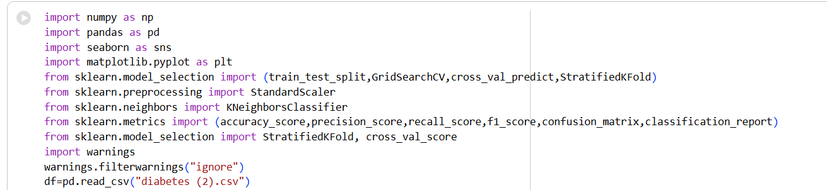

df.head()
This block displays the first five rows of the Diabetes dataset. It provides an initial understanding of the available columns, features, and their values. It is useful for checking whether the dataset has been loaded correctly.
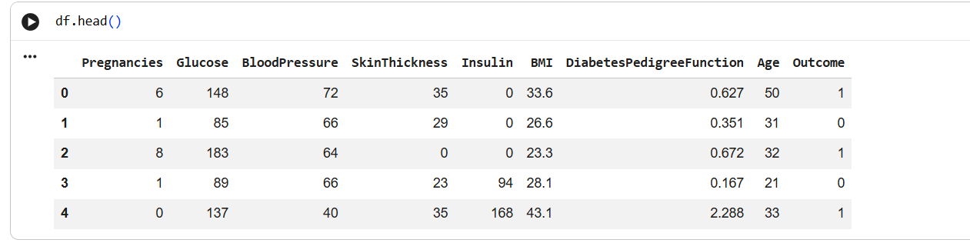

df.tail()
This block displays the last five rows of the dataset. It helps verify the records at the end of the DataFrame and provides another view of the dataset structure. It can also help confirm that the dataset has been loaded completely.
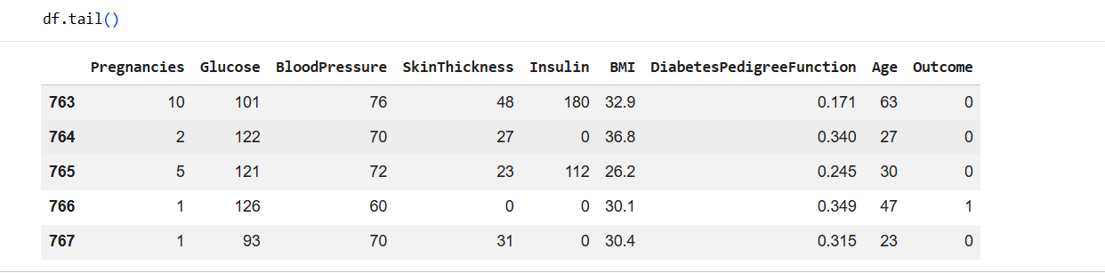

df.info()
This block displays important information about the dataset, including the number of rows, columns, data types, and non-null values. It helps identify the structure of the dataset and possible missing-value issues. This information is useful before beginning preprocessing.
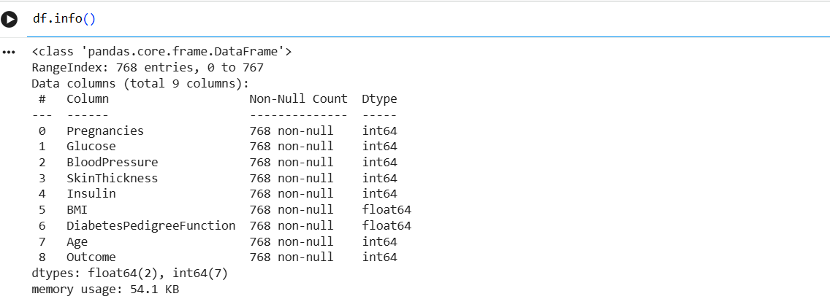

df.describe()
This block generates descriptive statistics for the numerical features. It displays values such as count, mean, standard deviation, minimum, maximum, and quartiles. These statistics help understand the distribution and range of the dataset features.
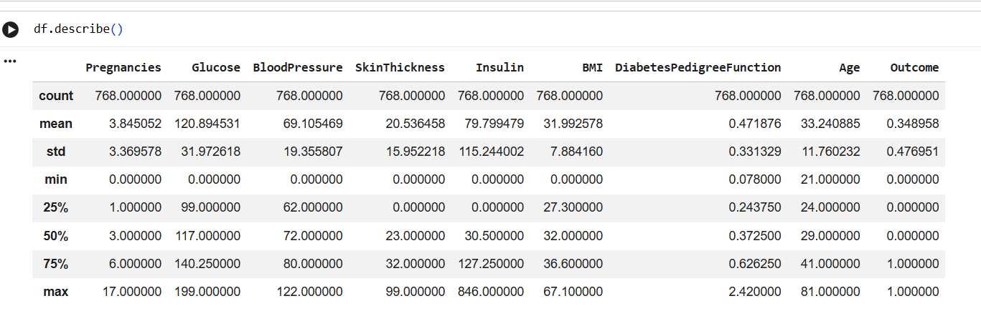

df.shape
This block displays the dimensions of the dataset in terms of the number of rows and columns. It provides a quick understanding of the size of the dataset. This is also useful for checking the amount of data available before model training.

df.isnull().sum()
This block checks whether the dataset contains missing values. It calculates the total number of null values present in each column. The result helps determine whether missing-value handling is required.
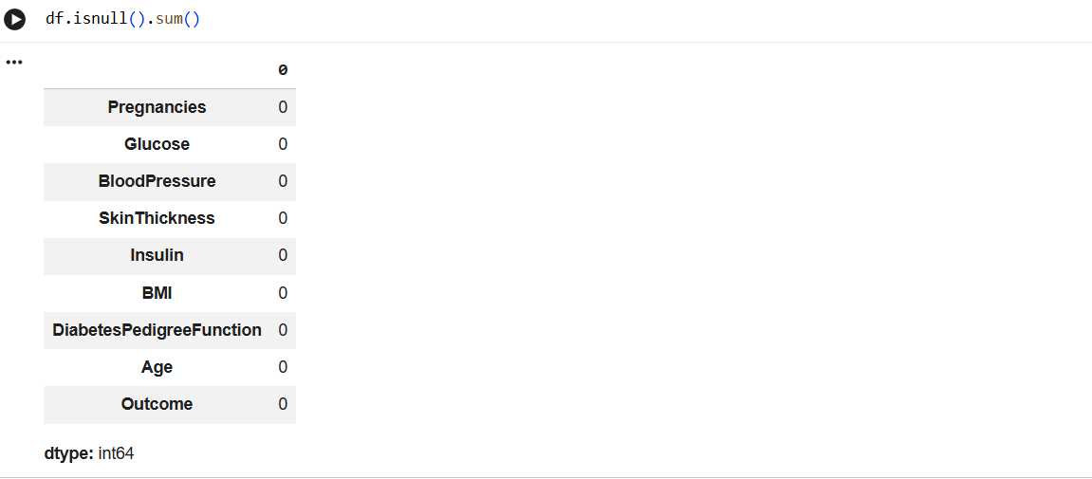

df.duplicated().sum()
This block checks for duplicate records in the dataset. It counts the number of rows that are completely duplicated. Identifying duplicates is important because repeated records can affect data analysis and model training.

df.drop_duplicates()
This block demonstrates the removal of duplicate records from the DataFrame. It returns the dataset after eliminating duplicate rows. It is used to examine the cleaned dataset without duplicate entries.
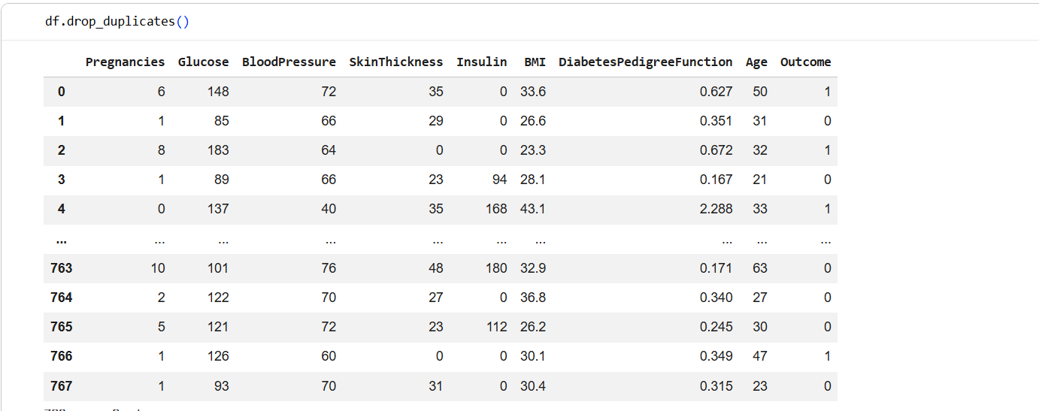

df.columns
This block displays the names of all the columns present in the dataset. It helps identify the input features and the target variable. In this dataset, the Outcome column is used as the target for classification.
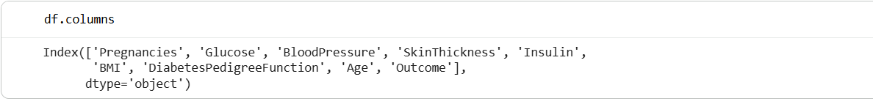

df.dtypes
This block displays the data type of each column. It helps determine whether the variables are numerical or categorical and whether any conversion is required. Correct data types are important for preprocessing and model development.
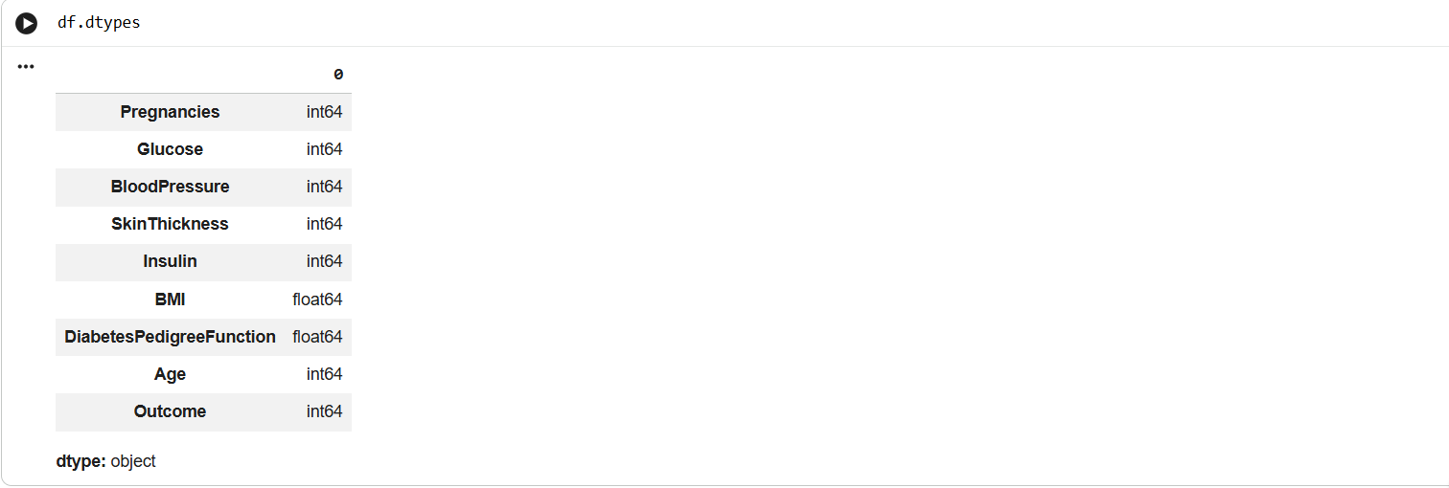

Pair Plot
This block generates a pair plot to visualize relationships between different numerical features. It allows multiple variables to be examined together and can reveal patterns, relationships, and distributions. It is useful for performing multivariate exploratory data analysis.
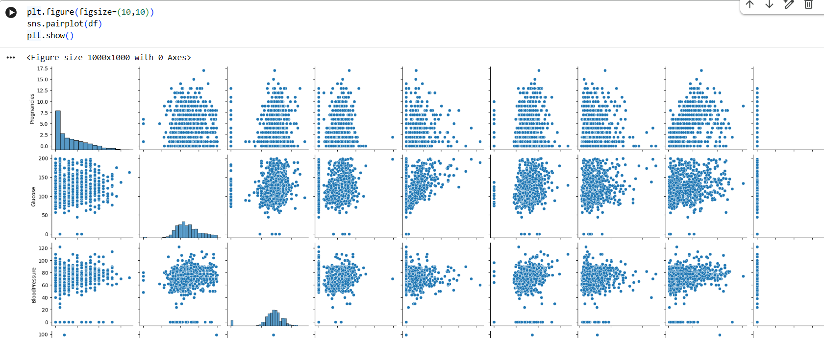

Histogram of Pregnancies
This block creates a histogram for the Pregnancies feature. It shows how the values are distributed across different ranges. The visualization helps understand the frequency and overall distribution of this variable.
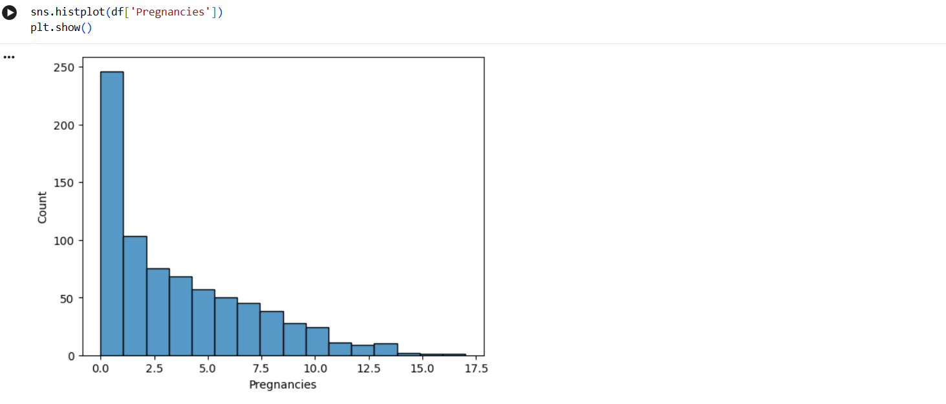

Box Plot of Pregnancies
This block creates a box plot for the Pregnancies feature. It displays the median, spread, quartiles, and possible extreme values. This helps in understanding the distribution and identifying potential outliers.
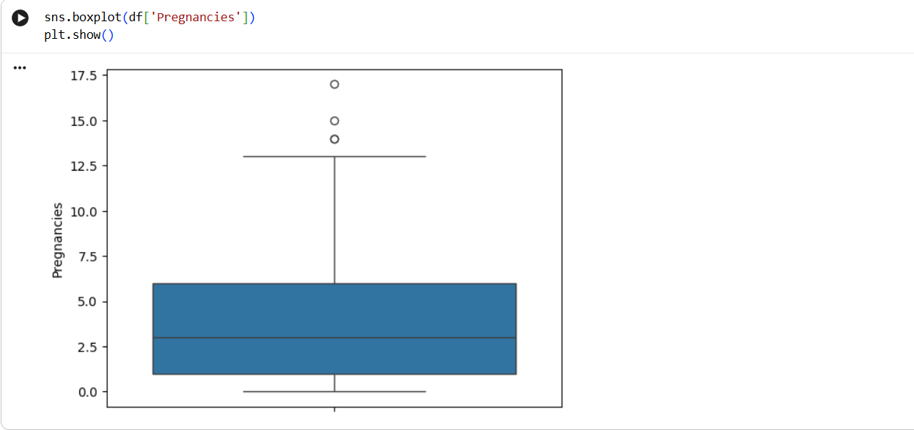

Checking Invalid Zero Values
This block checks the number of zero values in features such as Glucose, BloodPressure, SkinThickness, Insulin, and BMI. Zero values in these measurements may represent unavailable or invalid measurements. The block counts these values so that they can be handled during preprocessing.
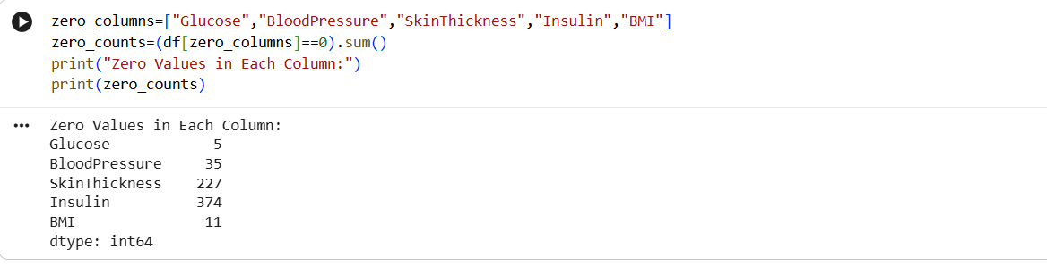

Replacing Zero Values with Missing Values
This block creates a cleaned copy of the original dataset and replaces invalid zero values with NaN. Treating these zero values as missing values allows them to be handled appropriately. This prepares the dataset for the next preprocessing step.
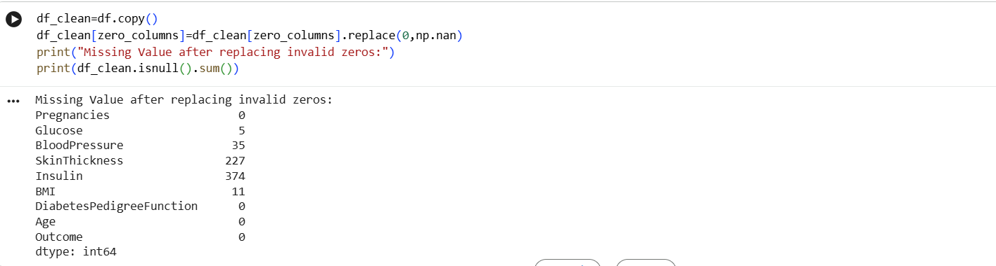

Median Imputation
This block replaces the missing values with the median value of their respective columns. Median imputation allows the dataset to retain the available records while reducing the effect of extreme values. After imputation, the missing-value count is checked again.
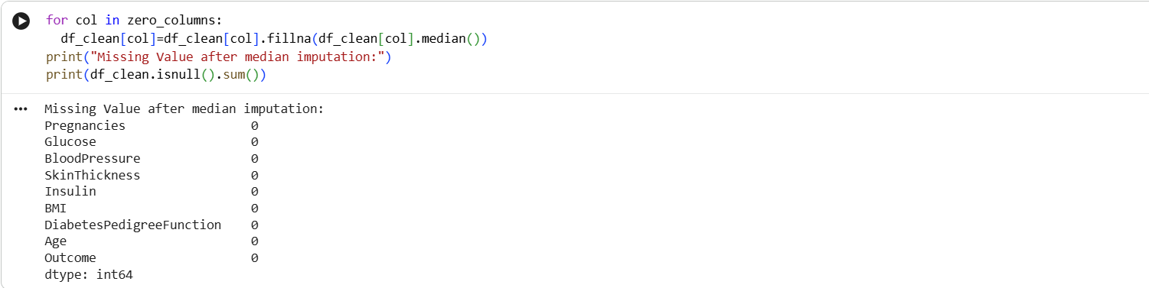

Correlation Heatmap
This block calculates the correlation between numerical features and represents the results using a heatmap. The numerical correlation values are displayed inside the heatmap. It helps identify relationships between different features and the target variable.
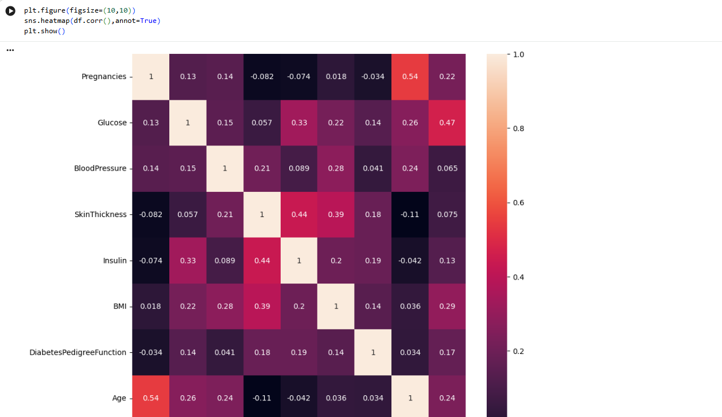

Separating Features and Target
This block separates the dataset into input features X and target variable y. The Outcome column is removed from X and stored separately in y. The features are used as inputs to the KNN model, while the outcome represents the class to be predicted.
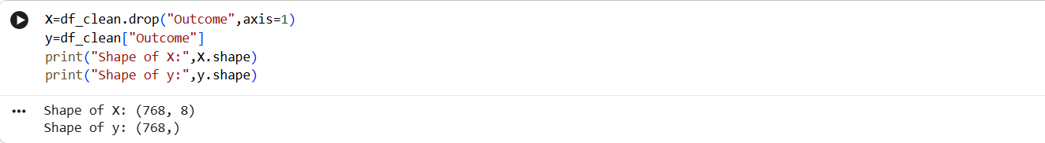

Train-Test Split
This block divides the dataset into training and testing sets. Around 80% of the data is used for training and 20% is used for testing. Stratification is used so that the class distribution remains similar in both datasets.
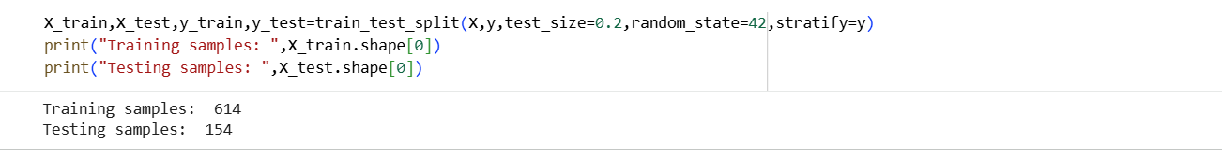

Checking Class Distribution
This block checks the distribution of the target classes in both the training and testing datasets. Normalized values are used to compare the proportions of the classes. This helps verify that the train-test split maintains a suitable class distribution.
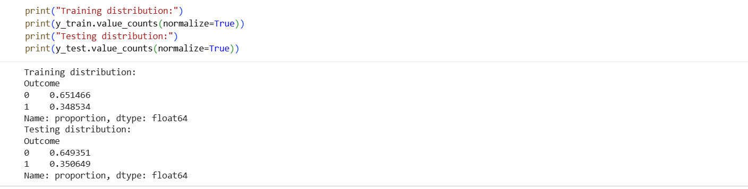

Standardizing Features
This block uses StandardScaler to standardize the input features. The scaler learns the mean and standard deviation from the training data and transforms the training features accordingly. The same scaling parameters are then applied to the test data, which is important because KNN depends on distance calculations.
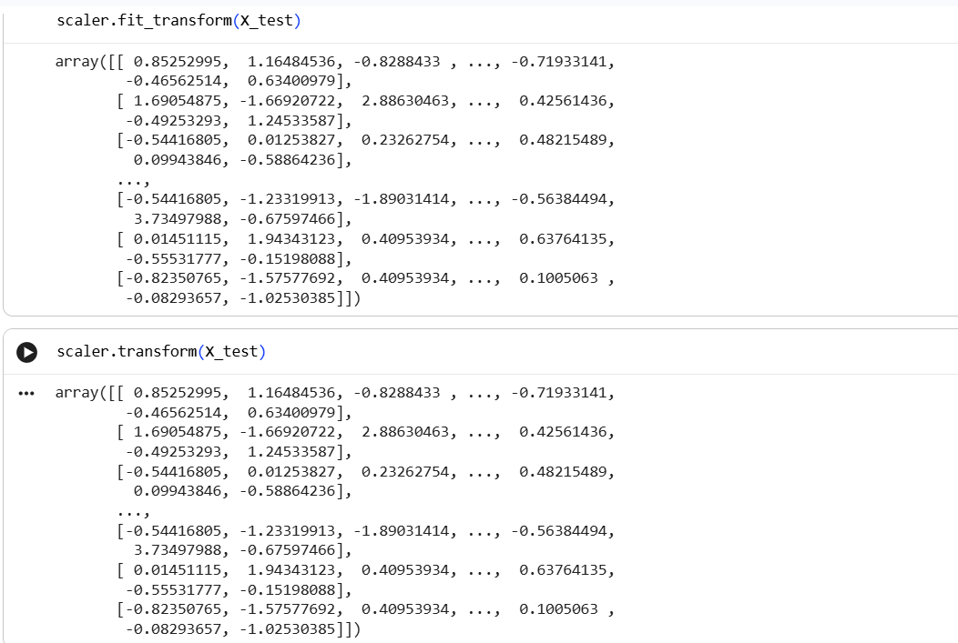

Comparing Original and Scaled Data
This block compares the original feature statistics with the standardized feature statistics. It shows how scaling changes the mean and standard deviation of the features. This demonstrates the effect of standardization before applying KNN.
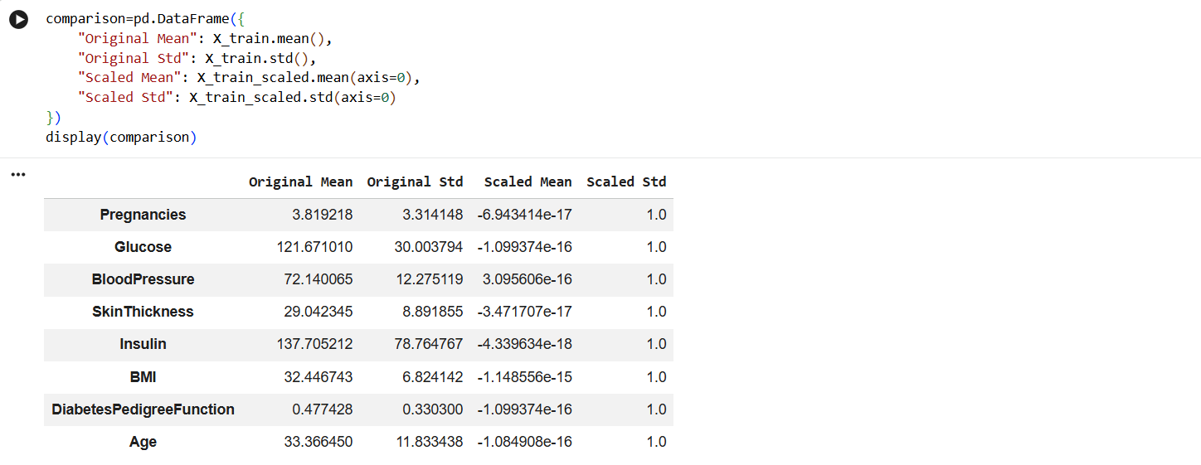

Setting the K Value
This block sets the value of K to 5. In KNN, K represents the number of nearest data points considered when determining the class of a new sample. This value is then used to create the initial KNN classifier.

Training the KNN Model
This block creates a KNN classifier using five nearest neighbors and trains it using the scaled training data. The fit() function is used to train the model. The trained model can then be used to classify unseen test samples.
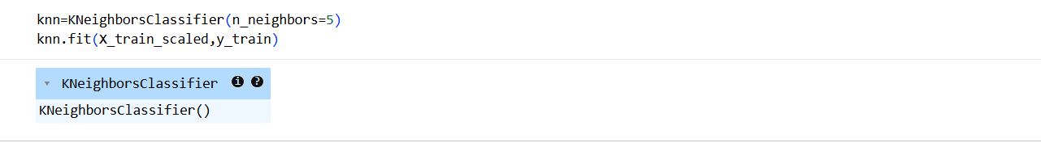

Generating Predictions
This block uses the trained KNN model to predict the class labels for the test dataset. The predict() function generates the predicted outcomes. The first few predictions are displayed to compare the model's output.
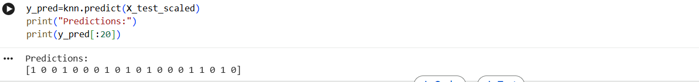

Predicting Class Probabilities
This block uses predict_proba() to calculate the probability of each test sample belonging to each class. It provides more information than simply predicting the class label. The first few probability values are displayed for examination.
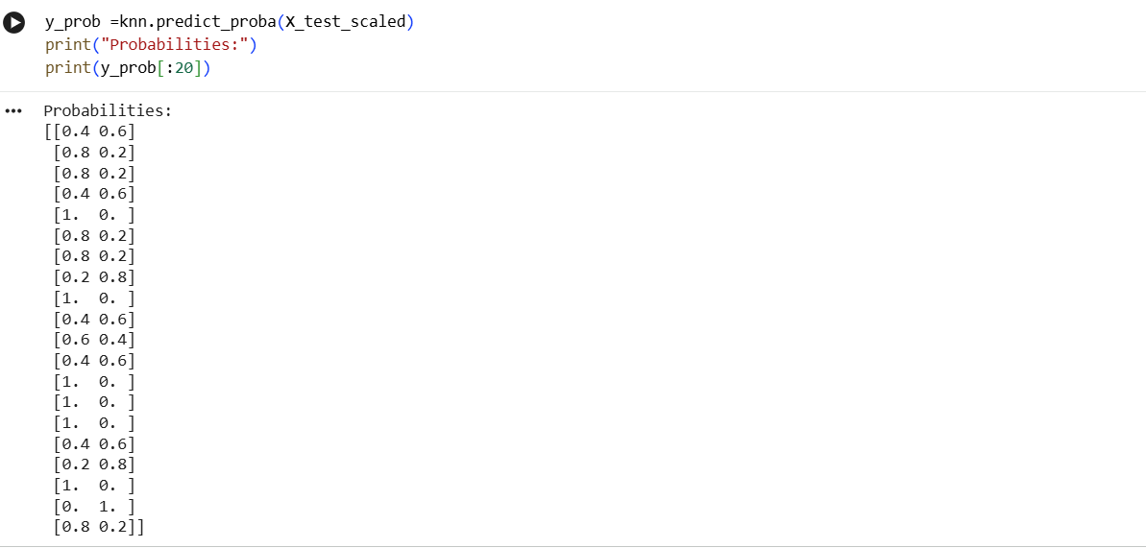

Calculating Accuracy
This block calculates the accuracy of the KNN model using the actual and predicted class labels. Accuracy represents the proportion of correctly classified samples out of all test samples. The calculated value is displayed as the model's accuracy.
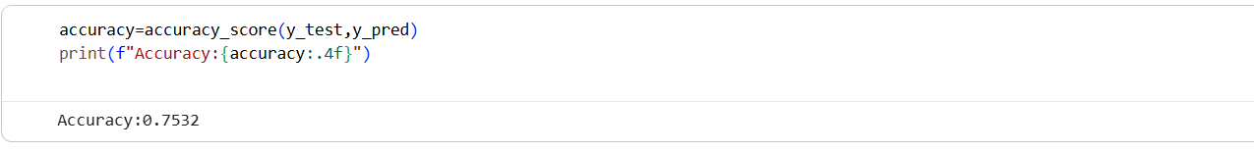

Calculating Precision
This block calculates the precision of the KNN classifier. Precision indicates how many of the samples predicted as the positive class were actually positive. The result helps evaluate the correctness of positive predictions.

Calculating Recall
This block calculates the recall of the KNN model. Recall indicates how many of the actual positive samples were correctly identified by the model. It is useful for understanding how effectively the model detects positive cases.

Calculating F1-Score
This block calculates the F1-score of the classifier using precision and recall. F1-score provides a combined measure of these two evaluation metrics. It is useful for evaluating classification performance when both precision and recall are important.
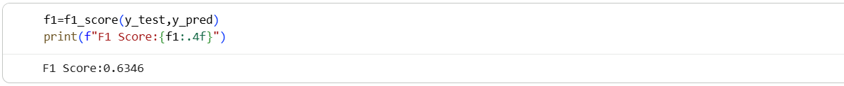

Classification Report
This block generates a classification report containing precision, recall, F1-score, and support for each class. It provides a detailed summary of the model's classification performance. The report helps compare the performance of the model for both outcome classes.
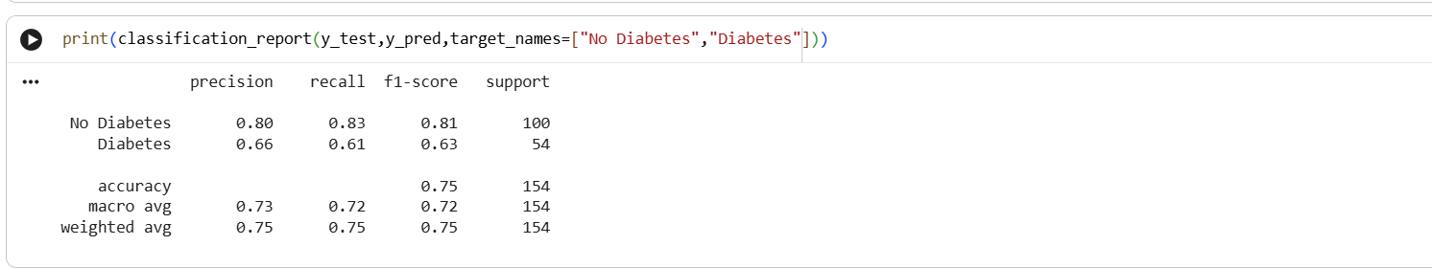

Confusion Matrix
This block calculates the confusion matrix using the actual and predicted outcomes. It shows the number of correct and incorrect predictions for each class. The matrix helps understand the types of classification errors made by the KNN model.
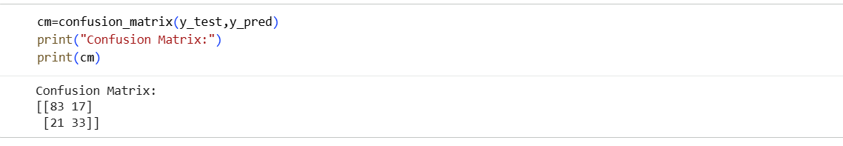

Visualizing the Confusion Matrix
This block displays the confusion matrix as a heatmap. The actual and predicted classes are shown along the axes, while the cells contain the prediction counts. This provides a clear visual representation of the model's classification results.
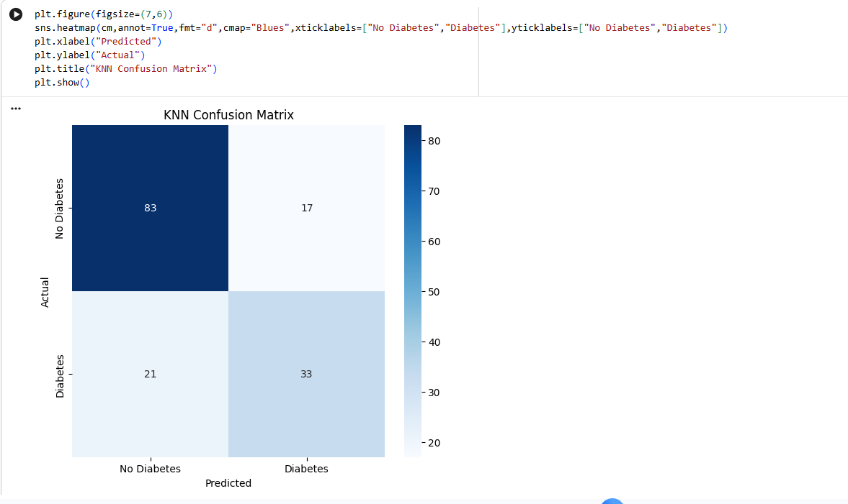

Testing Different K Values
This block tests different K values, ranging from 1 to 30, to observe their effect on model performance. A KNN model is trained and evaluated for each value of K. Training and testing accuracies are stored for comparison.
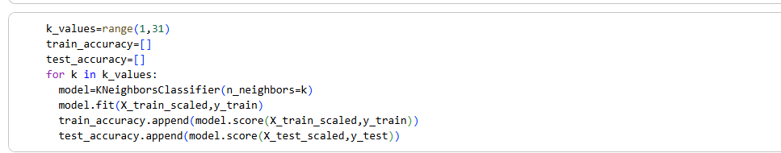

Plotting Accuracy Against K
This block plots training accuracy and testing accuracy for different K values. The graph helps visualize how changing the number of neighbors affects model performance. It can be used to identify a suitable K value based on testing performance.
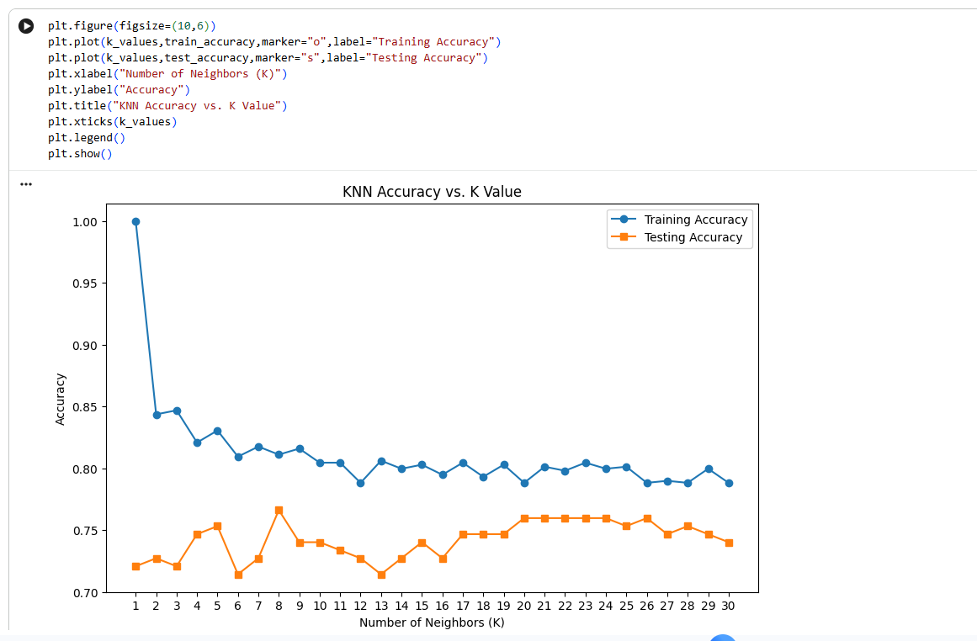

Finding the Best K Using Test Accuracy
This block identifies the K value that produces the highest testing accuracy. The position of the maximum accuracy is found and converted into the corresponding K value. The selected K and its accuracy are then displayed.
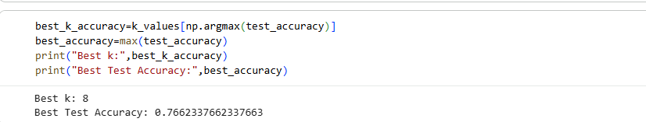

Cross-Validation for Different K Values
This block applies 5-fold stratified cross-validation to evaluate different K values. Each K value is tested across multiple folds, and the average accuracy is calculated. This provides a more reliable comparison of different K values than using only one train-test split.
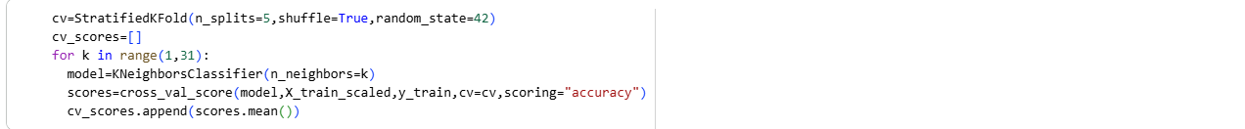

Finding the Best K Using Cross-Validation
This block identifies the K value with the highest average cross-validation accuracy. The corresponding K value and its cross-validation score are displayed. This provides another method for selecting a suitable number of neighbors.
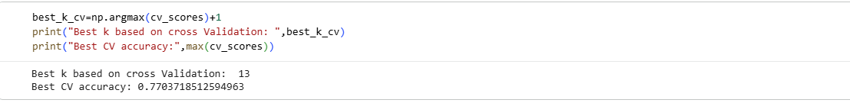

Defining Grid Search Parameters
This block defines different combinations of KNN hyperparameters for tuning. It considers different numbers of neighbors, weighting methods, distance metrics, and parameter values. These combinations are provided to GridSearchCV for systematic testing.
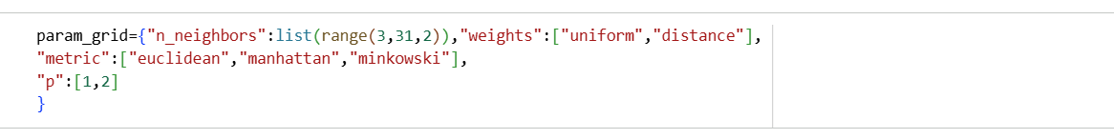

Performing GridSearchCV
This block uses GridSearchCV to evaluate different combinations of KNN hyperparameters using cross-validation. Accuracy is used as the evaluation metric. The grid search identifies the parameter combination that provides the highest cross-validation performance.
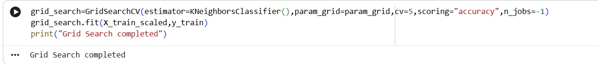

Displaying Best Parameters
This block displays the best hyperparameter combination identified by GridSearchCV. The result includes the selected number of neighbors, weighting method, distance metric, and other relevant parameters. These parameters are used to construct the optimized KNN model.
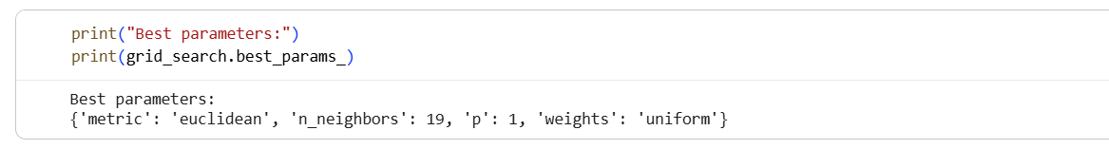

Displaying Best Cross-Validation Accuracy
This block displays the highest cross-validation accuracy obtained during GridSearchCV. It represents the performance of the best hyperparameter combination across the validation folds. This helps assess the effectiveness of the optimized configuration.
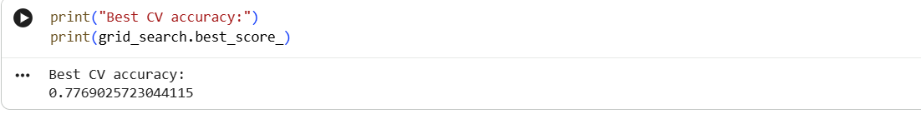

Selecting the Best KNN Model
This block retrieves the best KNN estimator identified by GridSearchCV. The optimized model is stored in the best_knn variable. This model contains the hyperparameters that produced the best cross-validation result.
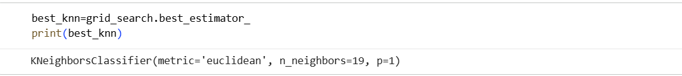

Generating Final Predictions
This block uses the optimized KNN model to generate predictions for the test dataset. It also calculates the probability of the positive class for the test samples. These predictions and probabilities can be used for the final evaluation of the optimized KNN model.

Viva Questions
- What is KNN and how does it work?
Ans: K-Nearest Neighbor (KNN) is a supervised machine learning algorithm used for classification. It classifies a new data point based on the classes of its nearest K data points. The class with the majority of neighbors is assigned to the new data point.
- Why is feature scaling important in KNN?
Ans: Feature scaling is important because KNN uses distance to find the nearest neighbors. Features with larger numerical ranges can dominate the distance calculation. StandardScaler is used in the notebook to bring the features to a comparable scale.
- What is the role of K in KNN?
Ans: K represents the number of nearest neighbors considered for making a prediction. A small K can make the model sensitive to individual data points, while a larger K considers more neighboring points. In the notebook, different K values are tested to find a suitable value.
- Why are zero values replaced with median values in the dataset?
Ans: Some zero values in features such as Glucose, BloodPressure, SkinThickness, Insulin, and BMI are treated as invalid or missing measurements. They are replaced with missing values and then filled using the median of the respective feature. This helps maintain the dataset without removing those records.
- What is GridSearchCV used for in the KNN model?
Ans: GridSearchCV is used to find suitable KNN hyperparameters by testing different combinations automatically. In the notebook, it tests parameters such as the number of neighbors, weighting method, and distance metric. It uses cross-validation to identify the combination with the best performance.

